**Travel Package Sales Performance**

**Name: K.BalaGanesh**

**Email:** [**Balaganesh0505@gmail.com**](mailto:Balaganesh0505@gmail.com)

**Github: Ganesh050599**

* **TOOLS USED:** Excel, Power Bi using with dashboard visualization
* **PROJECT OVERVIEW:** This project visualizes travel package sales and how many types of accommodations and transportations.
* **DATASET DESCRIPTION:**

**List of all column**s: Trip ID, Destination, start date, End date, Duration(days), Traveler name, Traveler gender, Traveler nationality, Accommodation type, Accommodation cost, Transportation type, Transportation cost.

**DATA COLLECTION**

To collect the data from Kaggle. From the Kaggle download the Data for the travel data. After downloading the data, Export the data to Excel.

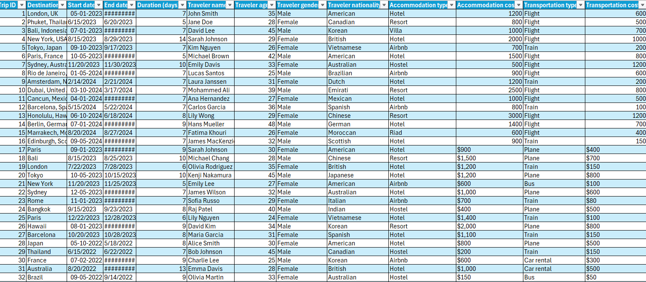

**DATA CLEANING:**

After collection of the data next, we need to clean the data.

* **Step 1**:

To check the null values. Replaced them with No data available.

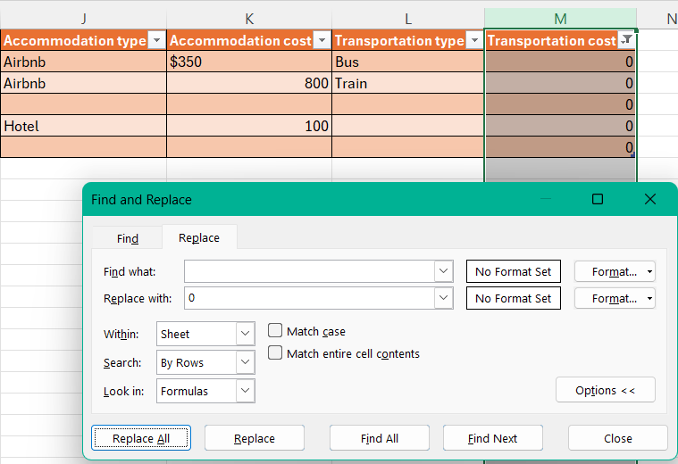

* **Step 2:**

Check the duplicate values. Clear them.

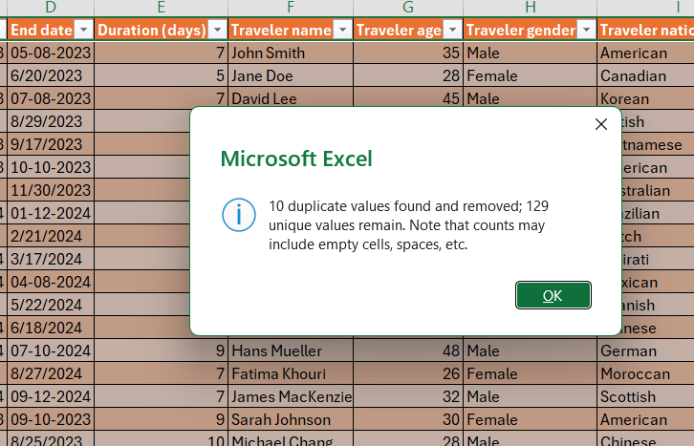

* **Step 3:**

Check the data and replace them with lower case or upper case values.

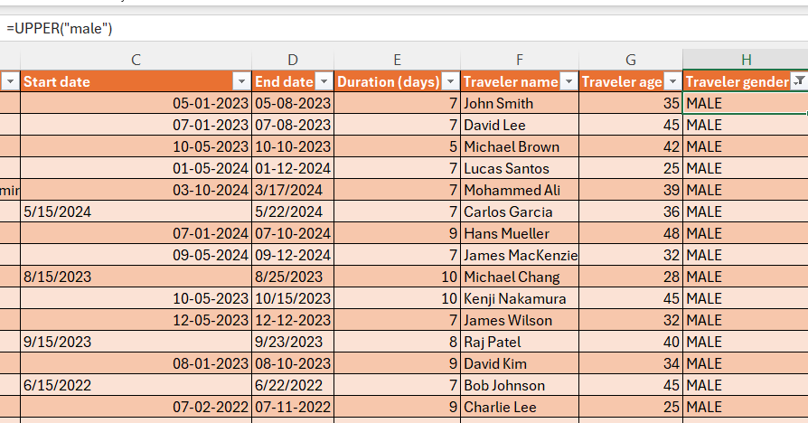

* **Step 4:**

To check the inconsistent data, use the Trim function.

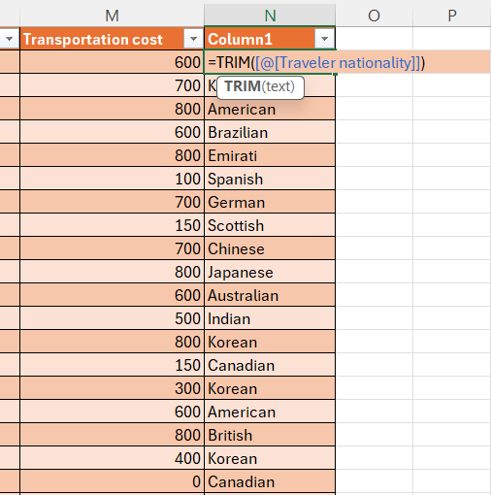

* **Step 5:**

Combine two columns to create a new column use a concatenate function.

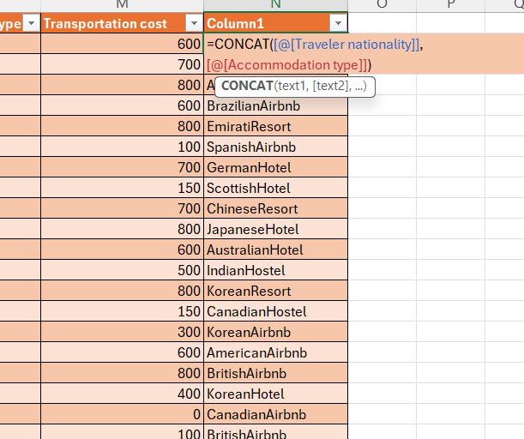

**DATA TRANSFORMATION:**

* Ater cleaning the data transform the data to Power Bi tool.

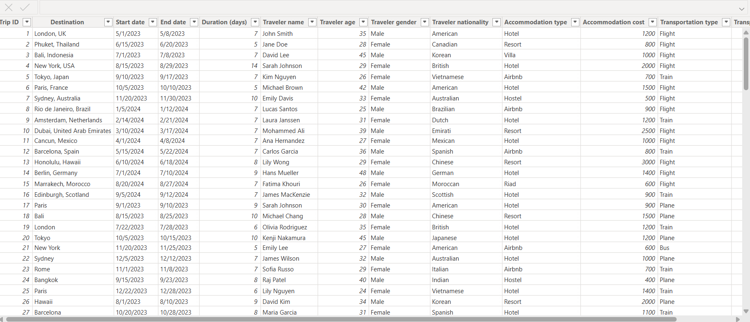

**DATA VISUALIZATION POWER Bi:**

* After transforming the data to Power Bi, Visualize the data in Power Bi by following the below steps

1. Use DAX functions

There are three types:

1. Calculated Measures (aggregate functions)
2. Calculated Columns
3. Calculated Tables

In Visualization there are different types of charts used.

1.Column chart

2.Bar chart

3. Pie chart

4.Donut chart

5.Line chart

6.Area chart

7.table

**COLUMN CHART:**

* Column charts are ideal for comparing values in different categories side by side.
* It’s easy to identify peaks and troughs visually in a dataset.

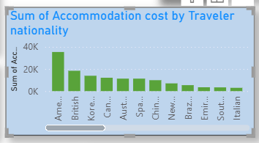

**Bar Chart:**

* Bar charts display data using horizontal bars, making them ideal for comparing lengthy category names or many categories at once.

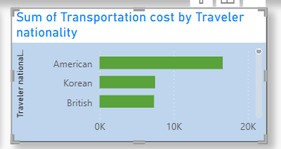

**Pie Chart:**

* Each slice size is proportional to the category's value compared to the total.
* Pie charts work best with 3–6 categories. Too many slices can make it hard to read.

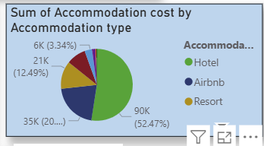

**Donut chart:**

* A Donut Chart in Excel is similar to a Pie Chart but with a hole in the centre, making it look like a donut
* It's used to show proportions of categories as parts of a whole, just like a pie chart, but with additional formatting flexibility.

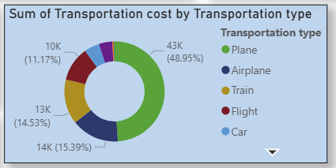

**Line chart:**

* Line charts are perfect for showing how data changes over time.
* You can plot more than one line to compare trends across different categories.

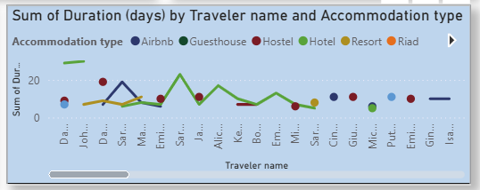

**Area chart:**

* It helps highlight the total value trend and how it grows over time.
* Stacked area charts can show how individual parts contribute to the total.

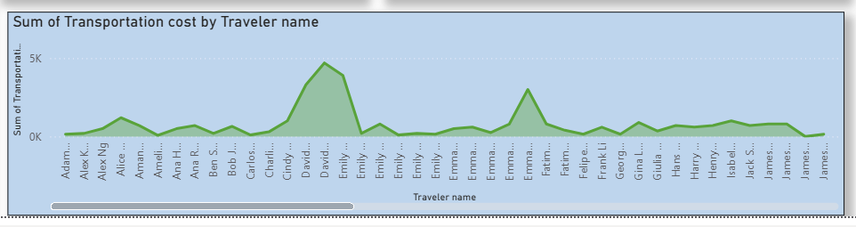

**Table:**

* Tables automatically apply a header row with filter buttons and alternating row colours for readability.
* When you add new rows or columns, Excel tables auto-expand and update any formulas or references using structured references.

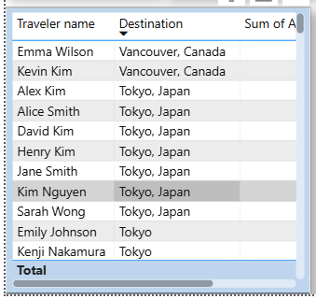

**Cards:**

* Displays one important number (like a total, average, or count).
* Displays multiple fields/values in one card layout.

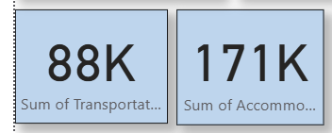

**Slicer:**

* A Slicer is a visual element that lets users filter data by selecting one or more values from a field — like dropdowns or checkboxes.
* Users can select categories like Region, Product, Date, or Customer, and the whole report updates instantly.
* There are 3 types of slicers.

1.Drop down

2.Vertical list

3.Tile.

* This is a dropdown slicer.

This type of slicer is used in different categories in a table.

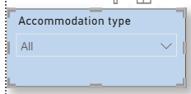

**Dashboard Preparation:**

